Wood-rock

Tapping a table with a small rock makes a sound.
Most of the sound is made by the table.

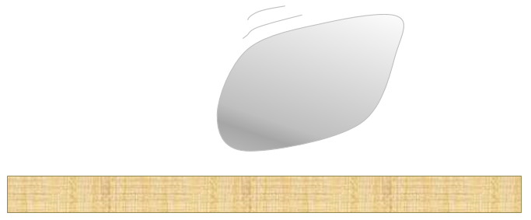

- Why is the sound made by the table a lot louder than the sound made by the rock?
For each statement, tick (✓) one column to show what you think.
Places |  | I am sure this is right | I think this is right | I think this is wrong | I am sure this is wrong
A | The table vibrates much more
B | The table is a lot bigger
C | It is the table that gets hit
D | The rock does not vibrate

Physics > Big idea PSL: Sound, light and waves > Topic PSL1: Sound and light > Key concept PSL1.1: Production and transmission of sound
Diagnostic question
Wood-rock

Overview
Learning focus: | Objects and materials can be made to vibrate to produce a sound that becomes louder as the size of vibration increases and higher pitched as the rate of vibration increases
Observable learning outcome: | Explain how sound is produced by objects that do not appear to vibrate
Question type: | Confidence grid
Key words: | Vibrate, vibration, loud, loudness

What does the research say?
Young children and some students may attribute the production of sound to the physical attributes of an object (for example, the tautness of a drum) or to the force used to make the sound (such as a hand hitting a drum), before developing an understanding that sound is caused by vibrations (Driver et al., 1994).
In a study of two-hundred-and-sixty 4-16 year old students Asoko, Leach and Scott ((1991) found that students use of vibrations to explain the source of sound increased with age, but this was also dependent on the context: 80% of students aged 11-16 used vibrations to explain sound when the vibrations were obvious (for example in a string); when air was vibrating in a horn this fell to 40%; and very few students used vibrations to explain the sound caused by knocking two small stones together.
This question explores whether students can apply the idea that vibration is needed to produce a sound, to situations where this is not at all obvious. Quite often students revert back to their earlier thinking when they are insecure in their understanding.
Ways to use this question
Students should complete the confidence grid individually. This could be a pencil and paper exercise, or you could use an electronic ‘voting system’ or mini white boards and the PowerPoint presentation.
If there is a range of answers, you may choose to respond through structured class discussion. Ask one student to explain why they gave the answer they did; ask another student to explain why they agree with them; ask another to explain why they disagree, and so on. This sort of discussion gives students the opportunity to explore their thinking and for you to really understand their learning needs.

Differentiation
You may choose to read the questions to the class, so that everyone can focus on the science. In some situations it may be more appropriate for a teaching assistant to read for one or two students.
Equipment
For the class:
- Two small rocks – to tap a table with, and to tap against each other
Expected answers
A is the only correct answer (B is partially correct, but not enough to be acceptable).
How to respond - what next?
The table is less stiff than the rock and vibrates with a bigger amplitude to make a louder sound. The particles in the rock are very firmly held together and for this reason vibrate very quickly with a small amplitude.
Answer B is right in the sense that a larger table is more flexible and can vibrate with a larger amplitude more easily – but hitting a large rock with a stick will still result in the louder sound being produced by the wood. Some students may think that bigger objects ‘contain’ more sound. When sound is transmitted through the air, many 11-14 year olds think of sound as a material substance (Whittaker, 2012).
In answer C, students are reverting back to earlier misunderstandings and answer D suggests that they are not able to fully generalise and apply their understanding to challenging examples.
If students have misunderstandings about vibrations in rocks, it might help to demonstrate tapping two small rocks together to hear them without the wood.
A demonstration of different vibrating objects that vibrate more or less obviously can lead students to an understanding that tighter and firmer objects (strings etc.) vibrate, but at higher frequencies and less loudly. The important point is to give students the opportunity to generalise these ideas. It can be helpful to give them the opportunity to summarise the patterns in their own words.
The following BEST ‘response activity’ could also be used in follow-up to this diagnostic question:
- Response activity: Touching note
Acknowledgments
Developed by Peter Fairhurst (UYSEG).
Images: UYSEG
References
Asoko, H. M., Leach, J. and Scott, P. H. (1991). A study of students' understanding of sound 5-16 as an example of action research. Annual Conference of the British Educational Research Association. Roehampton Institute, London.
Driver, R., et al. (1994). Making Sense of Secondary Science: Research into Children's Ideas, London, UK: Routledge.
Whittaker, A. (2012). Pupils think sound has substance - well, sort of ... School Science Review, 94(346), 3.

